TRIBHUVAN UNIVERSITY
INSTITUTE OF ENGINEERING
PURWANCHAL CAMPUS
DHARAN



ARTIFICIAL INTELLIGENCE

Lab Report I

Submitted by:  Gokarna Baskota  PUR075BEI013 | Submitted To:  Department of Electronics and Computer  Engineering

Lab 1: Introduction to Python
Python is a widely used high-level, general-purpose, interpreted, dynamic programming language. Its design philosophy emphasizes code readability, and its syntax allows programmers to express concepts in fewer lines of code than possible in languages such as C++ or Java.

- WAP to check if an input number is odd or even

Program:

input_num = int(input("Enter your nummber:\n"))

if(input_num % 2 == 0):
print(str(input_num) + " is even number.")

else:
print(str(input_num) + " is odd number.")

Output:

- WAP to input the percentage and display the division
>=80 → Distinction
>=65 → First Division
>=55 → Second Division
>=40 → Third Division
<40 → Fail

Program:

distic = 80
first = 60
second = 55
third = 40

percent = float(input("Enter percentage: "))

if(percent >= distic):
print("You got distiction.")

elif(percent >= first):
print("You got first division.")

elif(percent >= second):
print("You got second division.")

elif(percent >= third):
print("You got third division.")

elif(percent < third):
print("You failed.")

Output:

- WAP to calculate sum, diff, product and quotient between two input numbers using a single function.

Program:

def calculate(a, b):
return a+b, a-b, a*b, a/b

num1 = int(input("Enter first number: "))
num2 = int(input("Enter second number: "))

sum, diff, product, quatient = calculate(num1, num2)

print("Sum = ", sum, "\nDifference = ", diff)
print("Product = ", product, "\nQuatient = ", quatient)

Output:

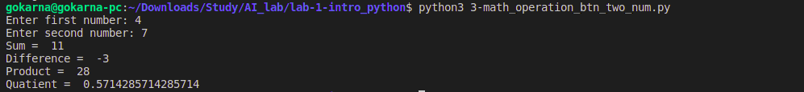
- WAP to display prime numbers from 1 to 100

Program:

from numpy import append

def list_prime(num_list):
prime = []

for i in num_list:
factors = 0
# print(i)
if(i == 1):
pass

elif(i == 2):
prime.append(i)

else:
for j in range(2,i+1):
temp = str(i/j)
dec = temp.split(".")[1]

if int(dec) == 0:
factors += 1

if(factors <= 1):
prime.append(i)
return prime

num_list = range(1, 101)
prime = list_prime(num_list)
print(prime)

Output:

- WAP to enter the marks of 10 students and display it.

Program:

st_info = {}
num = 1

for i in range(num):
name = input("Enter student Name: ")
st_info[name] = input("Enter student Mark: ")

print("SN \t| Name \t\t\t\t| Mark")
print("-----------------------------------------------")
i = 1
for key in st_info.keys():
print("{} \t| {} \t\t| {}".format(i, key.upper(), st_info[key]))
i = i + 1

Output:

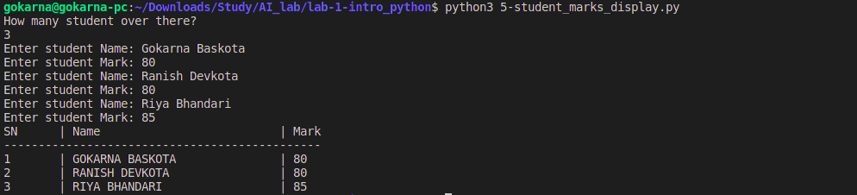
- WAP to calculate the factorial of an input number.

Program:

def fact_recur(a):
if(a == 0 or a == 1):
return 1
prod = a * fact_recur(a-1)
return prod

def fact_iterative(a):
mul = 1
if(a == 0 or a == 1):
return 1
for i in range(1,a+1):
mul = mul*i
return mul

num = int(input("Enter number: "))

factorial = fact_recur(num)
print("Factorial is {}".format(factorial))

factorial = fact_iterative(num)
print("Factorial is {}".format(factorial))

Output:

- WAP to ask for a sentence and count the number of words.

Program:

text = input("Write Sentence and Press Enter:\n")

words = []
sentence = text.split(".")

for sub_sen in sentence:
sen = sub_sen.split(",")

for wrd in sen:
for data in wrd.split(" "):
if data != '':
words.append(data)

print(words)
print("Words count in sentance is: {}".format(len(words)))

Output:

- WAP to sort the list {5, 4, 11, 13, 51}

Program:

def bubble_sort(array):
l = len(array)

for i in range(l-1):
t_len = len(array[i:l-1])
for j in range(t_len):
if array[j] >= array[j + 1]:
temp = array[j + 1]
array[j + 1] = array[j]
array[j] = temp
# array[j],array[j+1] = array[j+1], array[j]
return array

array = [5, 99, 11, 13, 51]
array = bubble_sort(array)
print(array)

Output:

- WAP program to sum all the items in a list.

Program:

val = int(input("How many numbers in the list: "))
list_val = []

for i in range(val):
data = int(input("Enter {} number: ".format(i+1)))
list_val.append(data)

summation = 0
for num in list_val:
summation = summation + num

print(summation)

Output:

- WAP program to get the largest number from a list.

Program:

arr = [88, 99, 77, 13, 51]
array = arr

print(array)
l = len(array)

for j in range(l-1):
if array[j] >= array[j + 1]:
temp = array[j + 1]
array[j + 1] = array[j]
array[j] = temp

print(array[-1])

Output:

- WAP to ask for a sentence and calculate the frequency of characters in the sentences.

Program:

text = input("Write Sentence and Press Enter:\n")

l = len(text)
char_dct = {}

for i in range(l):
temp_len = len(text[i:l])
temp = []
temp.append(text[i])

for j in range(temp_len-1):
# print(text[i], text[i+j+1])
if text[i] == text[i+j+1]:
temp.append(text[i])

if text[i] not in char_dct:
char_dct[text[i]] = len(temp)

for key in char_dct:
print("Frequency of {} is {}".format(key, char_dct[key]))

Output:

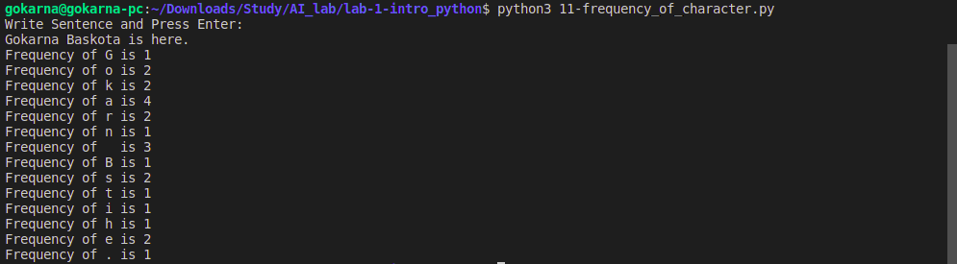
- WAP to find the sum of all items in a dictionary
Input: {'a': 100, 'b':200, 'c':300}
Output: 600
Input: {'x': 25, 'y':18, 'z':45}
Output: 88

Program:

dict_1 = {'a':100, 'b':200, 'c':500}
dict_2 = {'z':150, 'y':50, 'x':200}

def sum_dict(dict):
sum = 0
for key in dict:
sum = sum + dict[key]
return sum

sum = sum_dict(dict_1)
print("Sum of all items in dictionary is {}".format(sum))

sum = sum_dict(dict_2)
print("Sum of all items in dictionary is {}".format(sum))

Output:

- You are given a string and your task is to swap cases. In other words, convert all lowercase letters to uppercase letters and vice versa.

Program:

sentence = input("Write a sentence and press ENTER:\n")

# alternatevly:

new_sentence = sentence.swapcase()
print(new_sentence)

Output:

- You are given a string and your task is to swap cases. In other words, convert all lowercase letters to uppercase letters and vice versa.

Program:

tree1 = {
'A':['B', 'C'],
'B':['A','D', 'E'],
'C':['A', 'F'],
'D':['B', 'G'],
'E':['B', 'H'],
'F':['C'],
'G':['D'],
'H':['E']
}

tree2 = {
'Biratnagar':['Itahari', 'Biratchowk', 'Rangeli'],
'Itahari':['Biratnagar', 'Biratchowk', 'Dharan'],
'Dharan':['Itahari'],
'Biratchowk':['Biratnagar', 'Itahari', 'Kanepokhari'],
'Rangeli':['Biratnagar', 'Kanepokhari', 'Urlabari'],
'Kanepokhari':['Biratchowk', 'Rangeli', 'Urlabari'],
'Urlabari':['Kanepokhari', 'Rangeli', 'Damak'],
'Damak':['Urlabari']
}

tree2_wt = {
['Biratnagar', 'Itahari']: 22,
['Biratnagar', 'Biratchowk']: 30,
['Biratnagar', 'Rangeli']: 25,
['Itahari', 'Biratchowk']: 11,
['Itahari', 'Dharan']: 20,
['Biratchowk', 'Kanepokhari']: 10,
['Rangeli', 'Kanepokhari']: 25,
['Rangeli', 'Urlabari']: 40,
['Kanepokhari', 'Urlabari']: 12,
['Urlabari', 'Damak']: 6,
}

Output:

No Output!

